IOS Practice

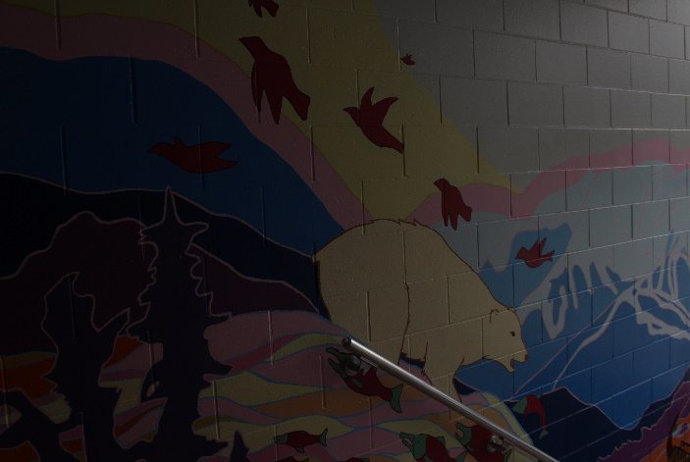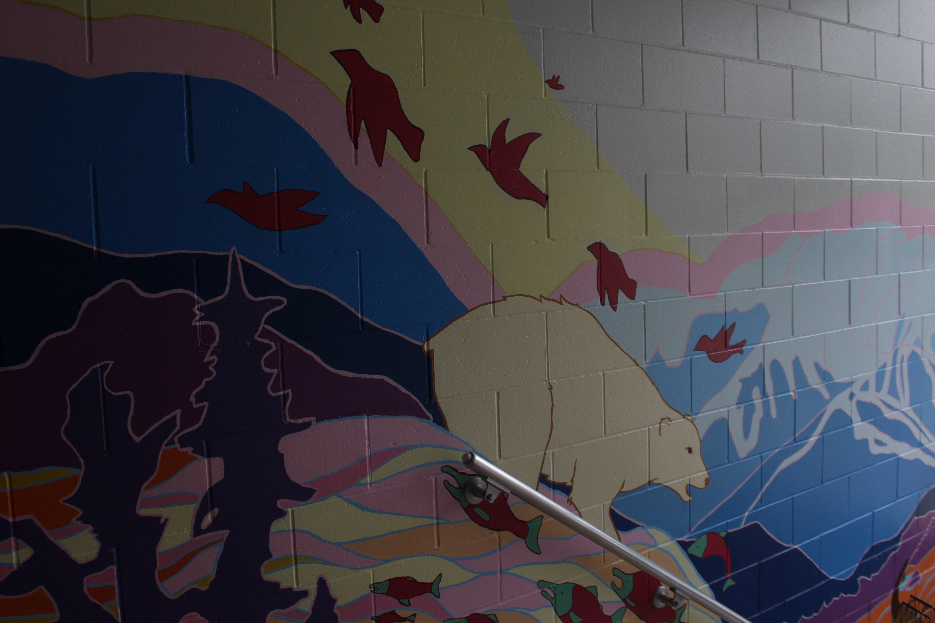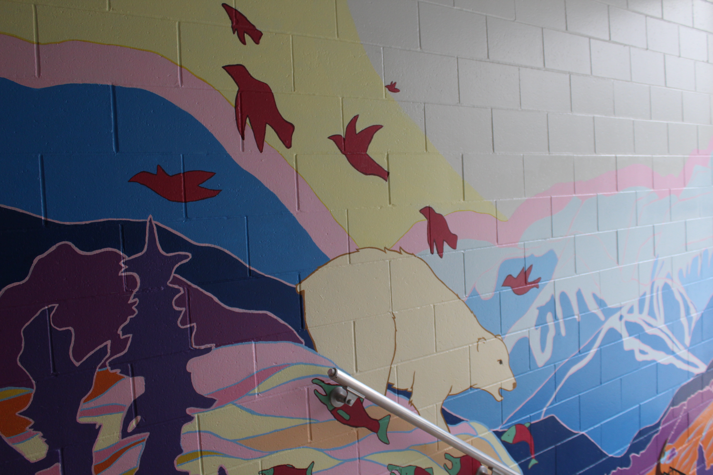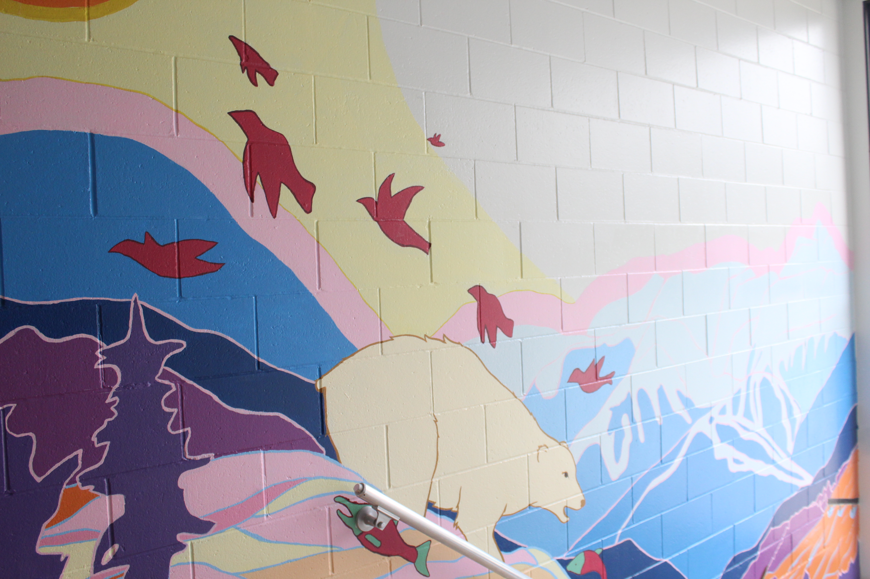
IOS: 3200
IOS: 800
IOS: 200
IOS: 100

IOS:
The IOS setting is used simply to create a brighter or dimmer lighting in your photos, this means that as you raise the IOS number, you are essentially making your camera more sensitive to the lighting in your surroundings. The opposite goes for lowering the IOS. When adjusting the IOS on your camera you may want to take into consideration: movement, amount of grain and the light in the area.

